Test Case: tc005_SPX_Dev5_Crear_Requisicion_Spot_Con_FAD_Tipo_Cobro_Project
Step 1 - Enter username and password and click to button Enter: Credentials Entered
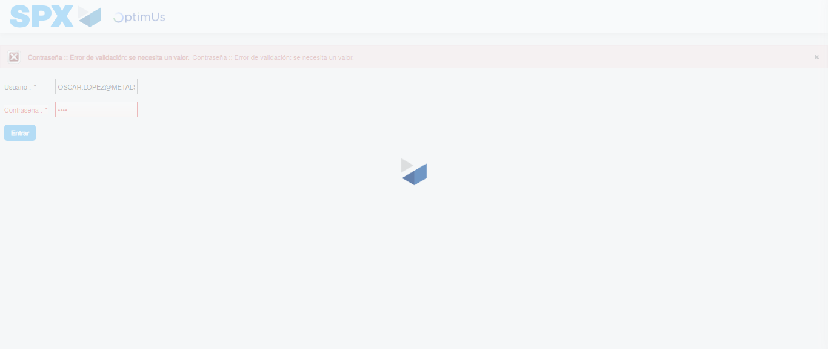Image file-name: QC_Testing-tc005_SPX_Dev5_Crear_Requisicion_Spot_Con_FAD_Tipo_Cobro_Project-1784572055711

Step 2 - Select to UEN and Access to Spot Buy Requisitions : UEN Correctly selected and Correct access
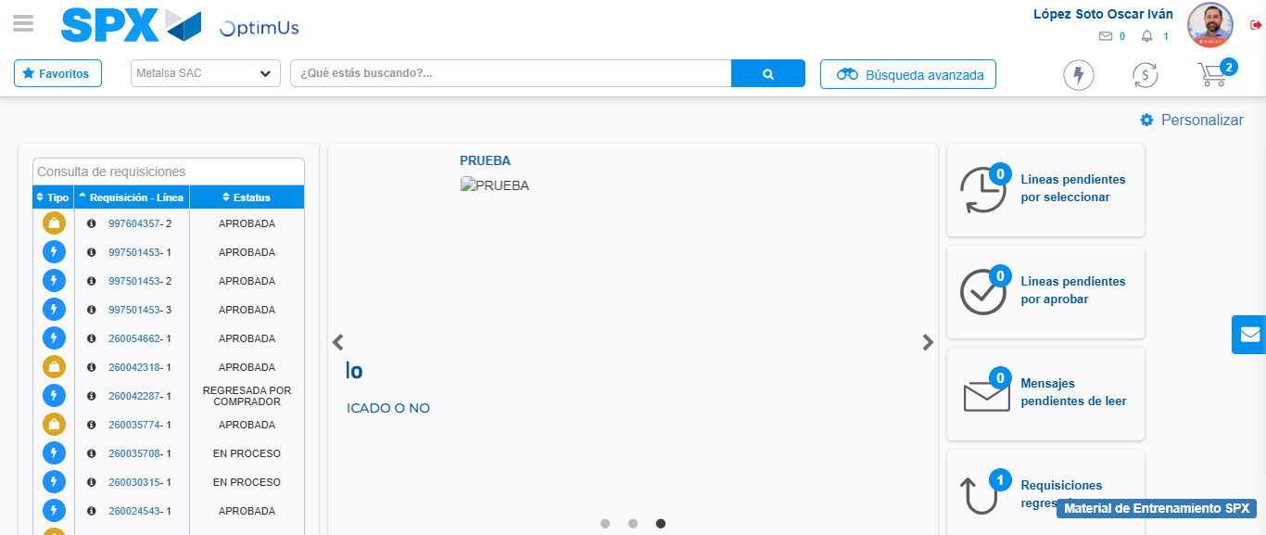Image file-name: QC_Testing-tc005_SPX_Dev5_Crear_Requisicion_Spot_Con_FAD_Tipo_Cobro_Project-1784572128340

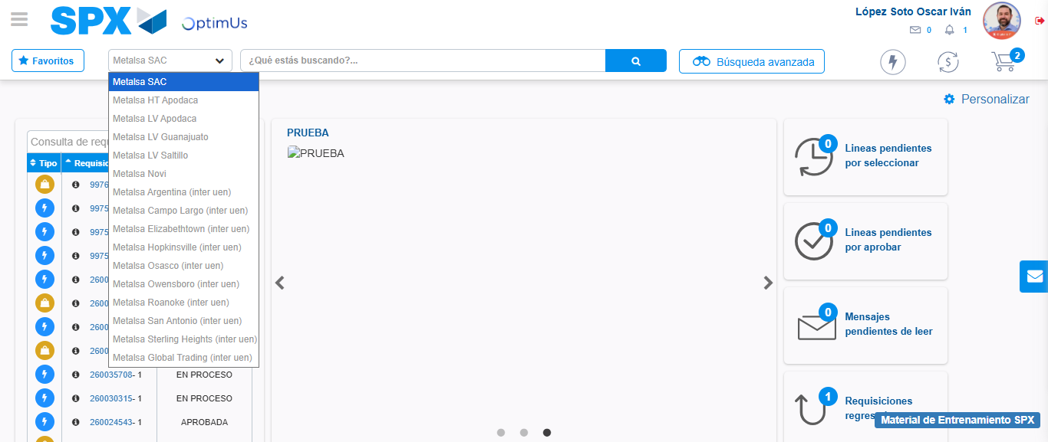Image file-name: QC_Testing-tc005_SPX_Dev5_Crear_Requisicion_Spot_Con_FAD_Tipo_Cobro_Project-1784572131100

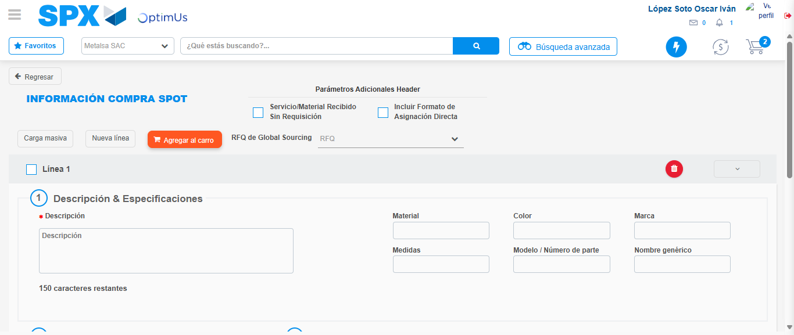Image file-name: QC_Testing-tc005_SPX_Dev5_Crear_Requisicion_Spot_Con_FAD_Tipo_Cobro_Project-1784572141278

Step 3 - Add FAD to Requisition: FAD Successfully Added
Image file-name: QC_Testing-tc005_SPX_Dev5_Crear_Requisicion_Spot_Con_FAD_Tipo_Cobro_Project-1784572141488

Image file-name: QC_Testing-tc005_SPX_Dev5_Crear_Requisicion_Spot_Con_FAD_Tipo_Cobro_Project-1784572141624

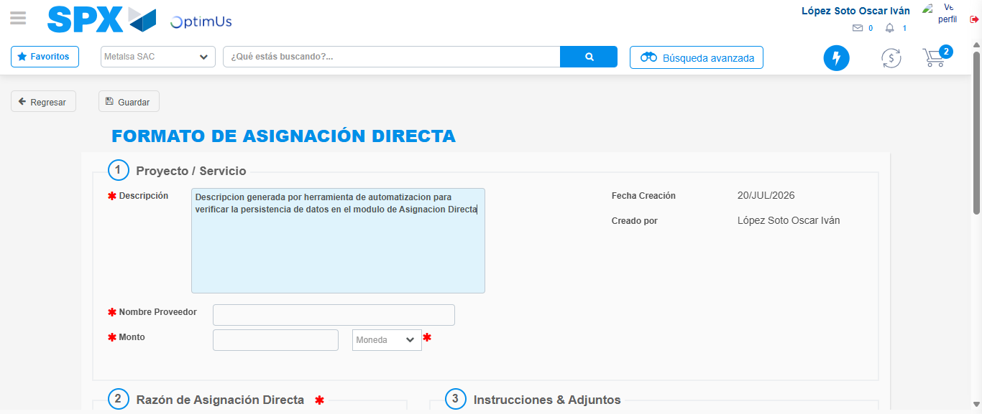Image file-name: QC_Testing-tc005_SPX_Dev5_Crear_Requisicion_Spot_Con_FAD_Tipo_Cobro_Project-1784572144351

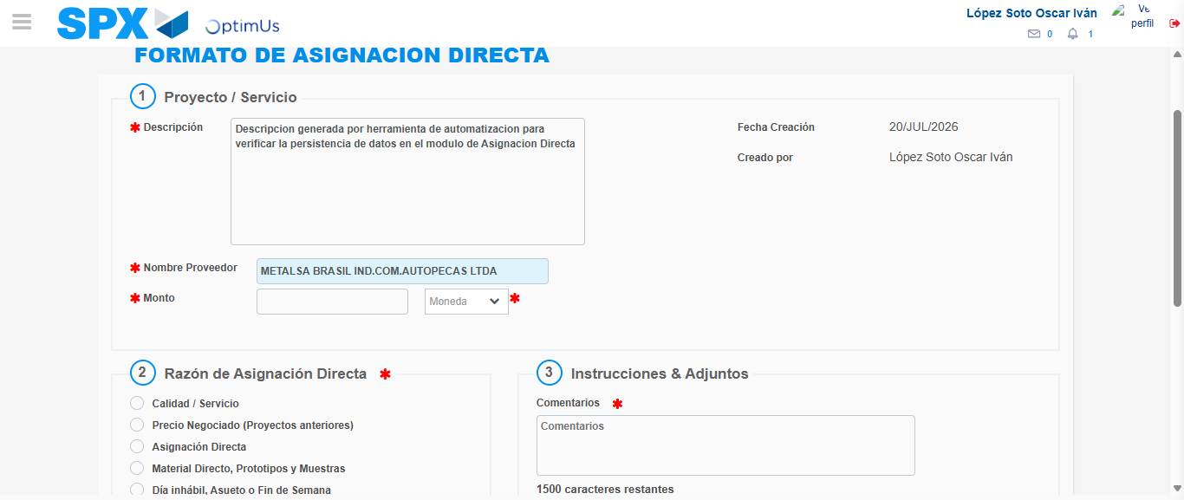Image file-name: QC_Testing-tc005_SPX_Dev5_Crear_Requisicion_Spot_Con_FAD_Tipo_Cobro_Project-1784572150725

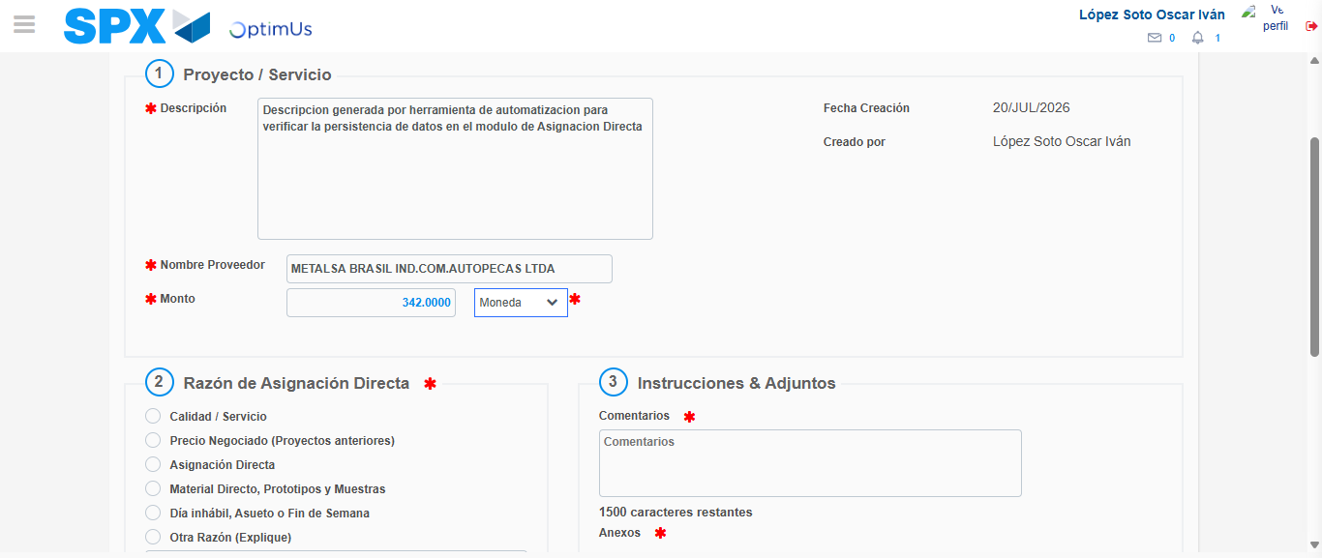Image file-name: QC_Testing-tc005_SPX_Dev5_Crear_Requisicion_Spot_Con_FAD_Tipo_Cobro_Project-1784572151108

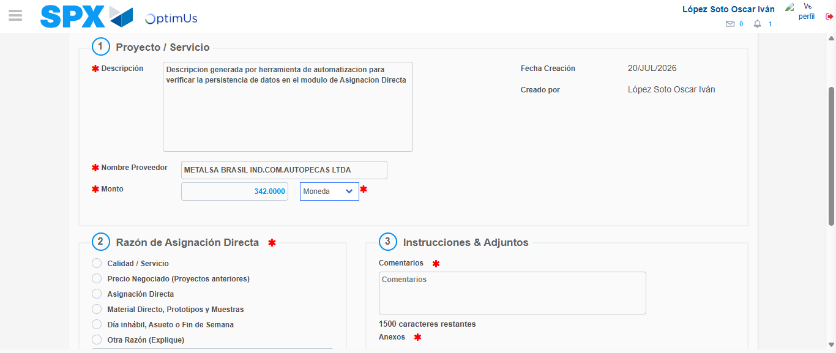Image file-name: QC_Testing-tc005_SPX_Dev5_Crear_Requisicion_Spot_Con_FAD_Tipo_Cobro_Project-1784572151293

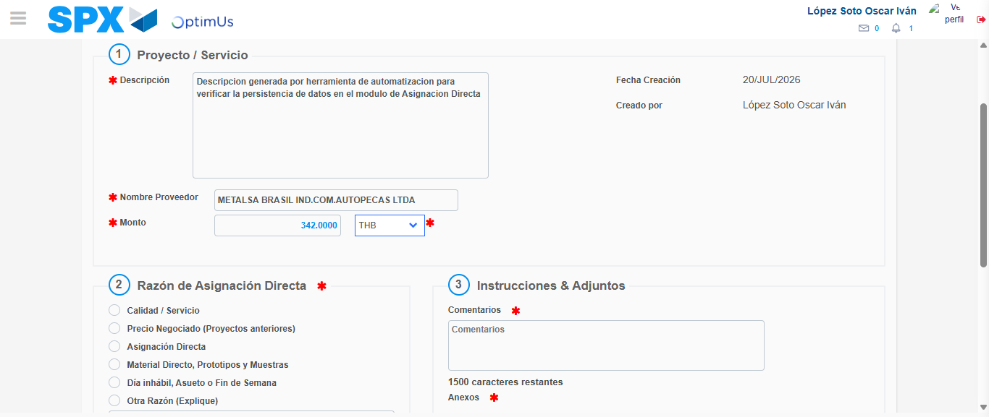Image file-name: QC_Testing-tc005_SPX_Dev5_Crear_Requisicion_Spot_Con_FAD_Tipo_Cobro_Project-1784572151647

Image file-name: QC_Testing-tc005_SPX_Dev5_Crear_Requisicion_Spot_Con_FAD_Tipo_Cobro_Project-1784572151828

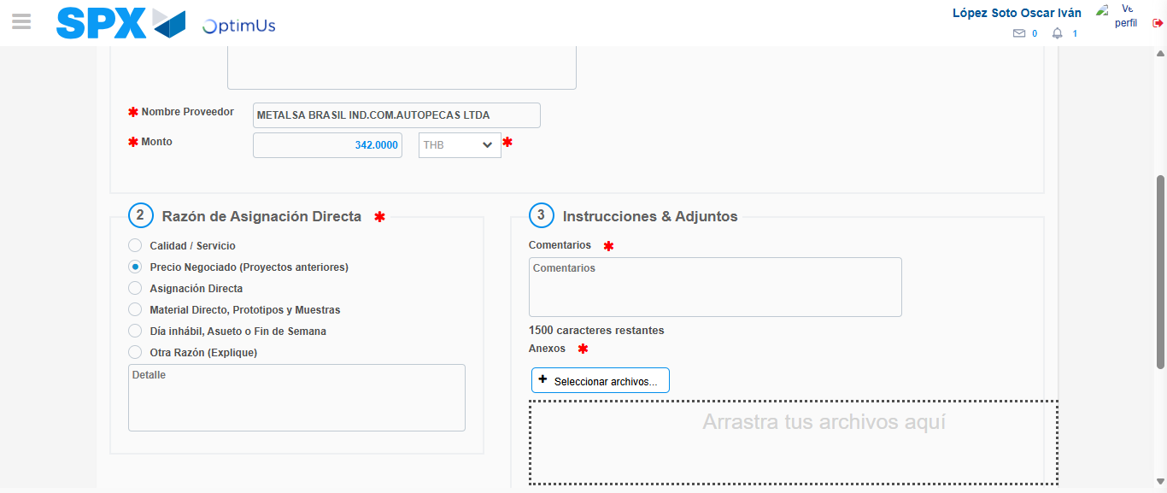Image file-name: QC_Testing-tc005_SPX_Dev5_Crear_Requisicion_Spot_Con_FAD_Tipo_Cobro_Project-1784572152648

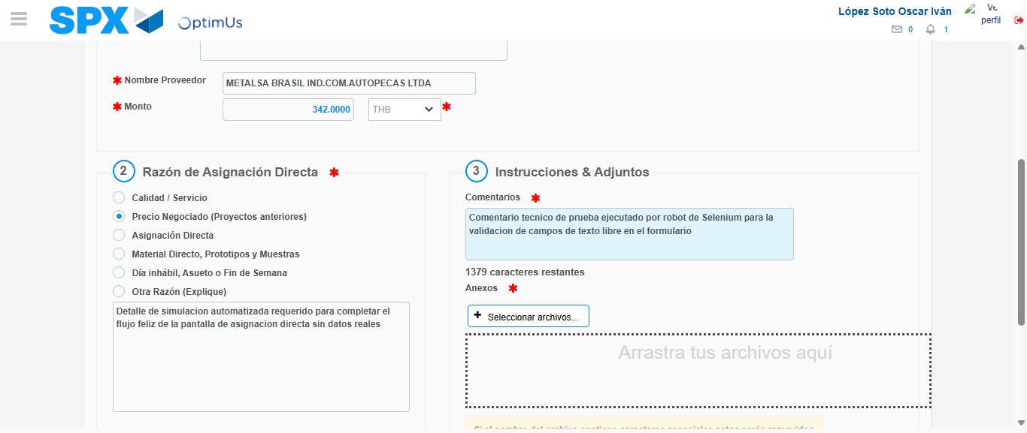Image file-name: QC_Testing-tc005_SPX_Dev5_Crear_Requisicion_Spot_Con_FAD_Tipo_Cobro_Project-1784572163908

Image file-name: QC_Testing-tc005_SPX_Dev5_Crear_Requisicion_Spot_Con_FAD_Tipo_Cobro_Project-1784572164706

Step 4 - Data Capture Spot Buy Requisition: Data captured correctly
Image file-name: QC_Testing-tc005_SPX_Dev5_Crear_Requisicion_Spot_Con_FAD_Tipo_Cobro_Project-1784572141488

Image file-name: QC_Testing-tc005_SPX_Dev5_Crear_Requisicion_Spot_Con_FAD_Tipo_Cobro_Project-1784572141624

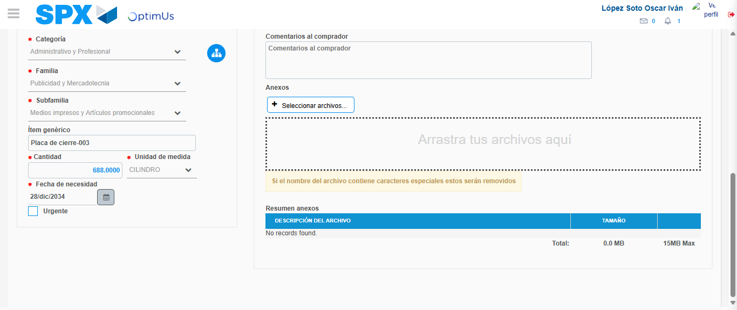Image file-name: QC_Testing-tc005_SPX_Dev5_Crear_Requisicion_Spot_Con_FAD_Tipo_Cobro_Project-1784572179552

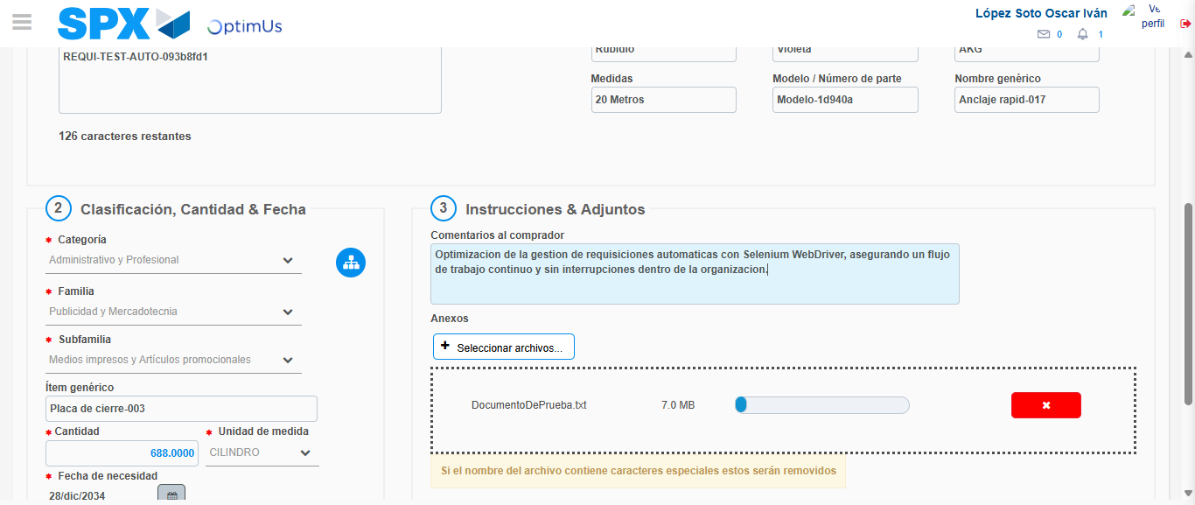Image file-name: QC_Testing-tc005_SPX_Dev5_Crear_Requisicion_Spot_Con_FAD_Tipo_Cobro_Project-1784572180535

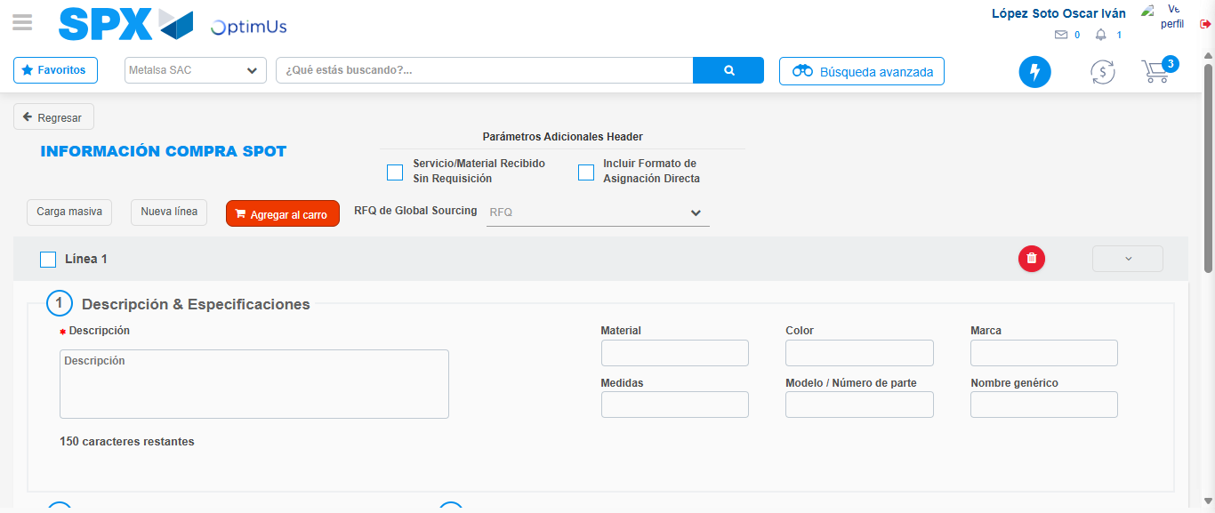Image file-name: QC_Testing-tc005_SPX_Dev5_Crear_Requisicion_Spot_Con_FAD_Tipo_Cobro_Project-1784572188593

Step 8 - Return to Main Page SPX : Return to Main Page SPX
Image file-name: QC_Testing-tc005_SPX_Dev5_Crear_Requisicion_Spot_Con_FAD_Tipo_Cobro_Project-1784572128340

Image file-name: QC_Testing-tc005_SPX_Dev5_Crear_Requisicion_Spot_Con_FAD_Tipo_Cobro_Project-1784572131100

Image file-name: QC_Testing-tc005_SPX_Dev5_Crear_Requisicion_Spot_Con_FAD_Tipo_Cobro_Project-1784572141278

Image file-name: QC_Testing-tc005_SPX_Dev5_Crear_Requisicion_Spot_Con_FAD_Tipo_Cobro_Project-1784572190790

Image file-name: QC_Testing-tc005_SPX_Dev5_Crear_Requisicion_Spot_Con_FAD_Tipo_Cobro_Project-1784572190915

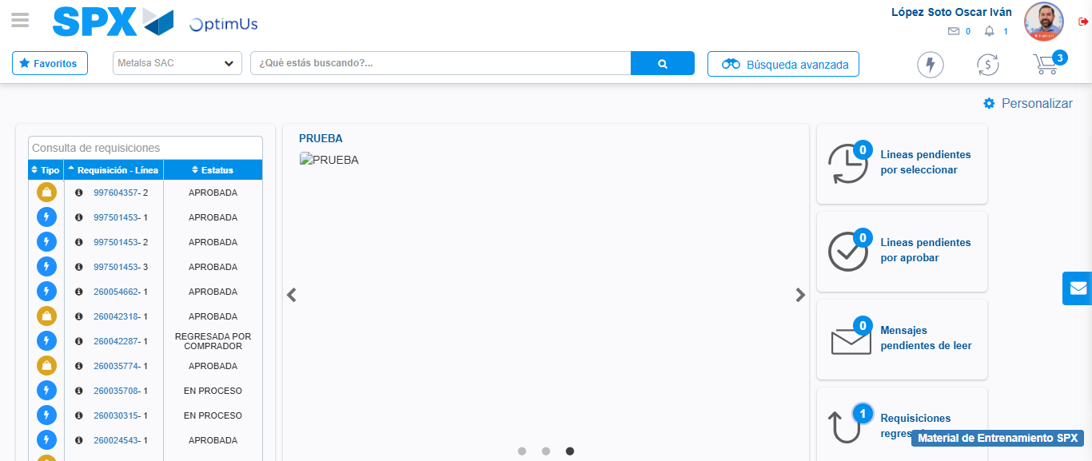Image file-name: QC_Testing-tc005_SPX_Dev5_Crear_Requisicion_Spot_Con_FAD_Tipo_Cobro_Project-1784572212109

Step 9 - Log Out : Log Out SPX
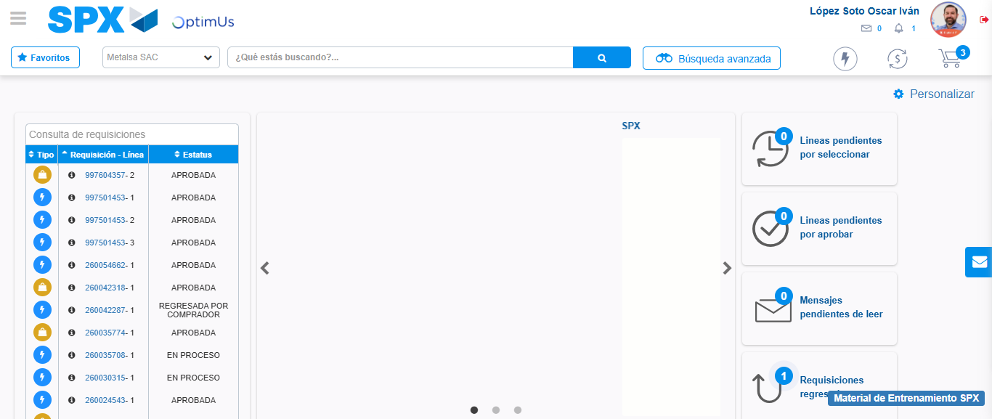Image file-name: QC_Testing-tc005_SPX_Dev5_Crear_Requisicion_Spot_Con_FAD_Tipo_Cobro_Project-1784572212398

